Report
Of
Virtual Logistics Data Analysis Intern

Submitted
To
School of Computer Science and Engineering
IILM University, Greater Noida, U.P.

In partial fulfilment of the requirement of degree of
B.Tech CSE



By
Roll Number of Student:2410030181
Name of Student: AYUSH BHATI
Batch: 2024-2028

CANDIDATE’S DECLARATION

I, Ayush Bhati do hereby declare that the internship report titled “Virtual Logistics Data Analysis Intern” has been completed by me to fulfil the requirement for the award of the degree of Bachelor of Technology in CSE. All the references have been quoted and I have not taken as such any material from any other source. I affirm to you that this report is my own and has not been submitted to any other institute for any degree/diploma requirement and further I shall be solely responsible for any kind of copyright violation in this regard.

Student Name Ayush Bhati
Roll No.2410030181

ACKNOWLEDGEMENT

I am using this opportunity to express my gratitude to everyone who supported me throughout the Internship Program. I am thankful for their aspiring guidance, invaluably constructive criticism and friendly advice during this work. I am sincerely grateful to them for sharing their truthful and illuminating views on a number of issues related to this work.
I express my gratitude to my parents for their blessings.

Student Name Ayush Bhati
Roll No..2410030181
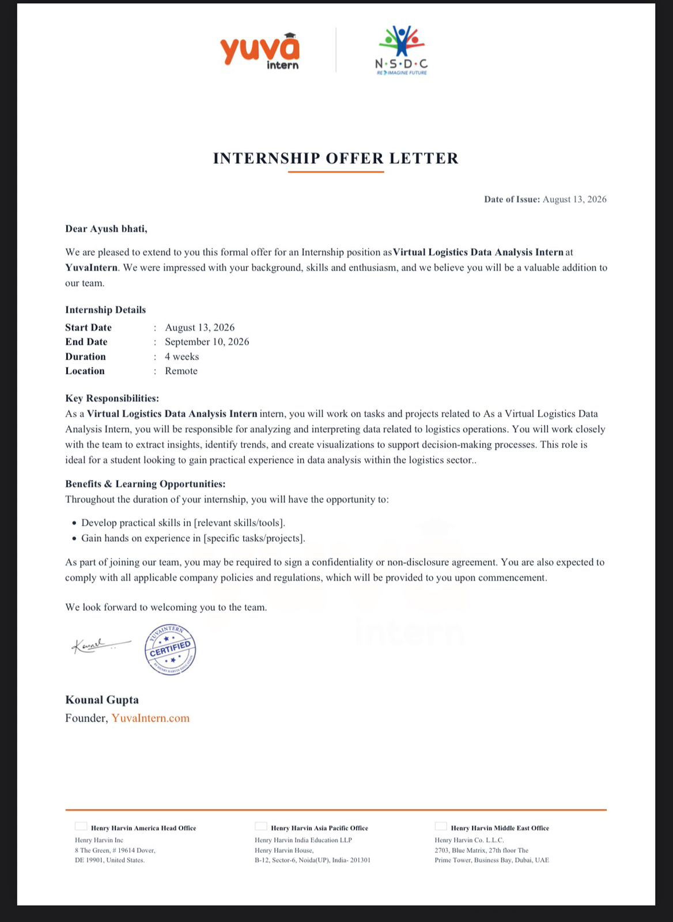

INTERNSHIP PROJECT REPORT
Project Title
Logistics Data Analysis and Exploratory Data Analysis
Organization
YuvaIntern
Internship Role
Virtual Logistics Data Analysis Intern
Intern
Ayush Bhati

1. Project Description
During my internship at YuvaIntern as a Virtual Logistics Data Analysis Intern, I worked on a project related to the analysis of logistics data. The main purpose of the project was to understand how raw logistics information can be studied and converted into useful insights.
Logistics involves many activities such as managing shipments, tracking deliveries, handling transportation information, and monitoring different operational factors. All these activities generate data. However, simply having a large amount of data is not enough. The data needs to be properly organized, cleaned, analyzed, and presented before it can be used to understand what is happening in the operation.
In this project, I followed a step-by-step data-analysis process. I first focused on understanding the dataset and the information contained in it. After that, I worked on data cleaning and preparation so that the data could be used for further analysis. Exploratory Data Analysis was then performed to understand different patterns, distributions, and relationships within the data.
I also used charts and graphs to present the analysis in a simpler way. These visualizations helped in understanding the data more clearly than looking at raw numbers alone.
Overall, the project gave me an opportunity to apply data-analysis concepts in a practical logistics-related situation and improve my understanding of how data can be used to study business operations.

2. Introduction
Data has become an important part of almost every business, and the logistics sector is no exception. Logistics companies handle a large amount of information every day. This information can be related to shipments, delivery times, transportation distances, costs, order quantities, and delivery status.
If this information is analyzed properly, it can provide a better understanding of how logistics operations are performing. It can also help in finding unusual patterns and areas that may require attention.
The main focus of my internship project was to analyze logistics data using Exploratory Data Analysis (EDA). EDA is an important stage of data analysis because it helps us understand a dataset before drawing conclusions from it. It involves checking the structure of the data, identifying missing or duplicate values, studying numerical and categorical variables, and finding relationships between different variables.
For this project, I used Python and its data-analysis libraries to work with the dataset. Different types of visualizations were also created to make the results easier to understand.
Working on this project helped me understand that data analysis is not only about writing code. It also requires understanding the problem, checking the quality of the data, selecting the right method of analysis, and interpreting the results correctly.

3. Organization Profile
My internship was completed at YuvaIntern, where I worked in the role of Virtual Logistics Data Analysis Intern. According to my internship certificate, I successfully completed the internship with YuvaIntern.
The certificate was issued on behalf of YuvaIntern by Kounal Gupta, Founder, YuvaIntern.com. It also recognizes my dedication, professionalism, willingness to learn, integrity, and commitment during the internship period.
The certificate also mentions Henry Harvin offices in the United States, India, and the Middle East.
My internship provided me with an opportunity to work on a logistics data-analysis project and gain practical exposure to the process of working with data.

4. Problem Statement
Logistics operations produce a large amount of data, but raw data is often difficult to understand without proper analysis. Looking at individual records does not easily reveal overall trends or relationships.
For example, it may be difficult to understand whether delivery time is related to transportation distance, whether certain types of shipments occur more frequently, or how different operational factors are connected.
Therefore, the problem addressed in this project was to develop a systematic approach for studying logistics data and finding useful patterns from it.
The project can be described through the following problem statement:
"To analyze logistics data using data-cleaning, exploratory analysis, and visualization techniques in order to understand operational patterns and generate meaningful insights."
The project was mainly focused on understanding the available data rather than developing a complete logistics management system.

5. Project Objectives
The main objectives of my project were:
- To understand the structure and contents of the logistics dataset.
- To inspect the dataset before beginning detailed analysis.
- To identify missing and duplicate data.
- To clean and prepare the dataset for analysis.
- To perform Exploratory Data Analysis.
- To study the distribution of important variables.
- To identify noticeable trends and patterns.
- To examine relationships between different logistics variables.
- To create graphs and charts for better understanding.
- To interpret the results obtained from the analysis.
- To gain practical experience with Python-based data analysis.
- To understand the role of data analysis in logistics operations.

6. Scope of the Project
The scope of this project is mainly related to analyzing and understanding logistics data.
The project covers the complete basic process of data analysis, starting from data inspection and preparation and ending with visualization and interpretation.
The major areas included in the project are:
Data Understanding
Understanding the columns, records, data types, and general structure of the dataset.
Data Cleaning
Checking for missing values, duplicate records, incorrect formats, and other inconsistencies.
Exploratory Analysis
Studying individual variables as well as relationships between different variables.
Statistical Analysis
Using basic statistical measures to understand the characteristics of numerical data.
Visualization
Creating different charts and graphs to represent the findings clearly.
Insight Generation
Interpreting the results and identifying patterns that can provide a better understanding of logistics operations.
The project is primarily an exploratory and analytical project. It is not intended to function as a complete real-time logistics management or tracking system.

7. Technologies and Tools Used
Several tools and technologies were used during the project.
Python
Python was the main programming language used for data analysis. I used Python because it provides several useful libraries for handling datasets and creating visualizations.
Pandas
Pandas was used for working with tabular data. It helped with tasks such as:
- Reading the dataset
- Viewing and inspecting records
- Checking missing values
- Removing duplicate records
- Grouping data
- Performing calculations
- Preparing data for analysis
NumPy
NumPy was used for numerical operations and calculations where required during the analysis.
Matplotlib
Matplotlib was used to create different types of graphs. These visualizations helped make the results easier to understand.
Seaborn
Seaborn was useful for creating statistical visualizations and examining relationships and distributions within the dataset.
Jupyter Notebook / Google Colab
A notebook environment was used to write and execute Python code while keeping the analysis, results, and visualizations together.

8. System Architecture
The project follows a simple data-analysis workflow. Instead of developing a traditional software application, the focus was on moving systematically from raw data to meaningful information.
Project Workflow
Logistics Dataset
↓
Data Loading
↓
Data Inspection
↓
Data Cleaning
↓
Data Preprocessing
↓
Exploratory Data Analysis
↓
Statistical Analysis
↓
Data Visualization
↓
Interpretation of Results
↓
Final Report
Explanation
First, the logistics dataset was loaded into the Python environment. The dataset was then inspected to understand its structure and identify any problems.
After inspection, the data was cleaned and prepared for analysis. Once the data was ready, different exploratory techniques were applied to understand the variables and their relationships.
The results were represented through charts and graphs. Finally, the observations from the analysis were interpreted and documented in the final report.
This workflow helped maintain a clear and organized approach throughout the project.

9. Methodology
The methodology followed during the project can be divided into several stages.
9.1 Understanding the Dataset
The first step was to understand what type of information was available in the logistics dataset. I examined the columns, number of records, data types, and general structure of the dataset.
This step was important because understanding the data is necessary before deciding how it should be analyzed.
9.2 Data Inspection
After loading the dataset, I inspected it to identify possible data-quality issues.
The inspection included checking:
- Number of rows and columns
- Column names
- Data types
- Missing values
- Duplicate records
- Basic statistical information
This provided an initial idea about the quality and structure of the data.
9.3 Data Cleaning
Data cleaning was performed before the main analysis.
The dataset was checked for missing values and duplicate records. Data types and formats were also reviewed to make sure that the variables could be analyzed correctly.
This stage was important because errors in the original data could lead to incorrect conclusions.
9.4 Exploratory Data Analysis
After preparing the dataset, I performed Exploratory Data Analysis.
EDA helped me understand how individual variables behaved and whether there were noticeable patterns in the data.
The analysis included different approaches.
Univariate Analysis
In univariate analysis, one variable was studied at a time.
For example, numerical variables could be examined using histograms or descriptive statistics, while categorical variables could be studied using frequency counts and bar charts.
Bivariate Analysis
Bivariate analysis was used to examine the relationship between two variables.
Examples include studying:
- Delivery time and distance
- Cost and distance
- Order quantity and cost
- Delivery status and other operational factors
This type of analysis helped in understanding whether changes in one variable were associated with changes in another.
Correlation Analysis
Correlation analysis was used where appropriate to understand the relationship between numerical variables.
A correlation does not automatically mean that one variable causes another, but it can help identify variables that move together and may deserve further investigation.
9.5 Data Visualization
Visualization was an important part of the project.
Different charts were used depending on the type of information being studied. Bar charts were useful for comparisons, histograms helped understand numerical distributions, scatter plots helped examine relationships, and other visualizations were used where appropriate.
The main purpose of creating these charts was to make the analysis easier to understand and communicate.
9.6 Interpretation
After creating the visualizations and completing the analysis, I reviewed the results and identified the main observations.
Instead of looking only at individual numbers, I focused on what the patterns could tell us about the logistics data.
9.7 Report Preparation
Finally, the complete process was organized into an internship report. The report describes the project background, objectives, tools, methodology, analysis process, and expected outcomes.

10. Expected Outcomes
The project is expected to provide several useful outcomes.
First, it provides a clearer understanding of the logistics dataset and the information contained within it. Data cleaning also makes the dataset more suitable for further analysis.
The exploratory analysis is expected to reveal important patterns in logistics operations. For example, the analysis can help identify differences in shipment activity, delivery times, distances, and costs.
Another important outcome is the use of visualization to communicate information more effectively. A well-designed chart can make a pattern much easier to recognize than a large table of numbers.
The project also helps demonstrate how different logistics variables may be related. Examining these relationships can provide useful direction for further analysis.
From a learning perspective, one of the most important outcomes of the project is the practical experience gained in handling data. I was able to understand the complete basic workflow of a data-analysis project, from inspecting raw data to presenting the final observations.
The internship also helped improve my skills in Python, data cleaning, exploratory analysis, visualization, problem-solving, and interpretation of data.

Conclusion
This internship project gave me an opportunity to understand the practical side of data analysis in the logistics domain. Rather than working only with theoretical concepts, I was able to follow a complete analytical workflow involving data inspection, cleaning, exploration, visualization, and interpretation.
The project showed me that the quality of the data is just as important as the analysis itself. Before creating graphs or calculating statistics, it is necessary to understand the dataset and make sure that the information is in a suitable form.
Working on logistics data also helped me understand how different operational factors can be studied using data. Visualization played an important role in this process because it made patterns and comparisons easier to recognize.
Overall, my internship as a Virtual Logistics Data Analysis Intern at YuvaIntern was a valuable learning experience. It helped me strengthen my technical knowledge as well as my analytical and problem-solving abilities. The experience has given me a stronger foundation for further learning and future work in the field of data analytics.

